Hi Faculty Mentors and Evaluators,

Industry Mentors are not completed reviewing Phase 01, it means they have not moved cards to 100% in workspace. Why?

So why they have not moved cards to 100% means, students are not moving cards to 90%. Industry Mentors can move cards only if the cards are there in 90% state (i.e., review state)

Industry Mentors now will move cards from 90% to 100% after checking required files properly submitted by students in GitHub or not.

**Case 01:** Students might have submitted Phase 01 files in GitHub, but they are not pushing cards in Kanban board to 90% (from backlog to review)

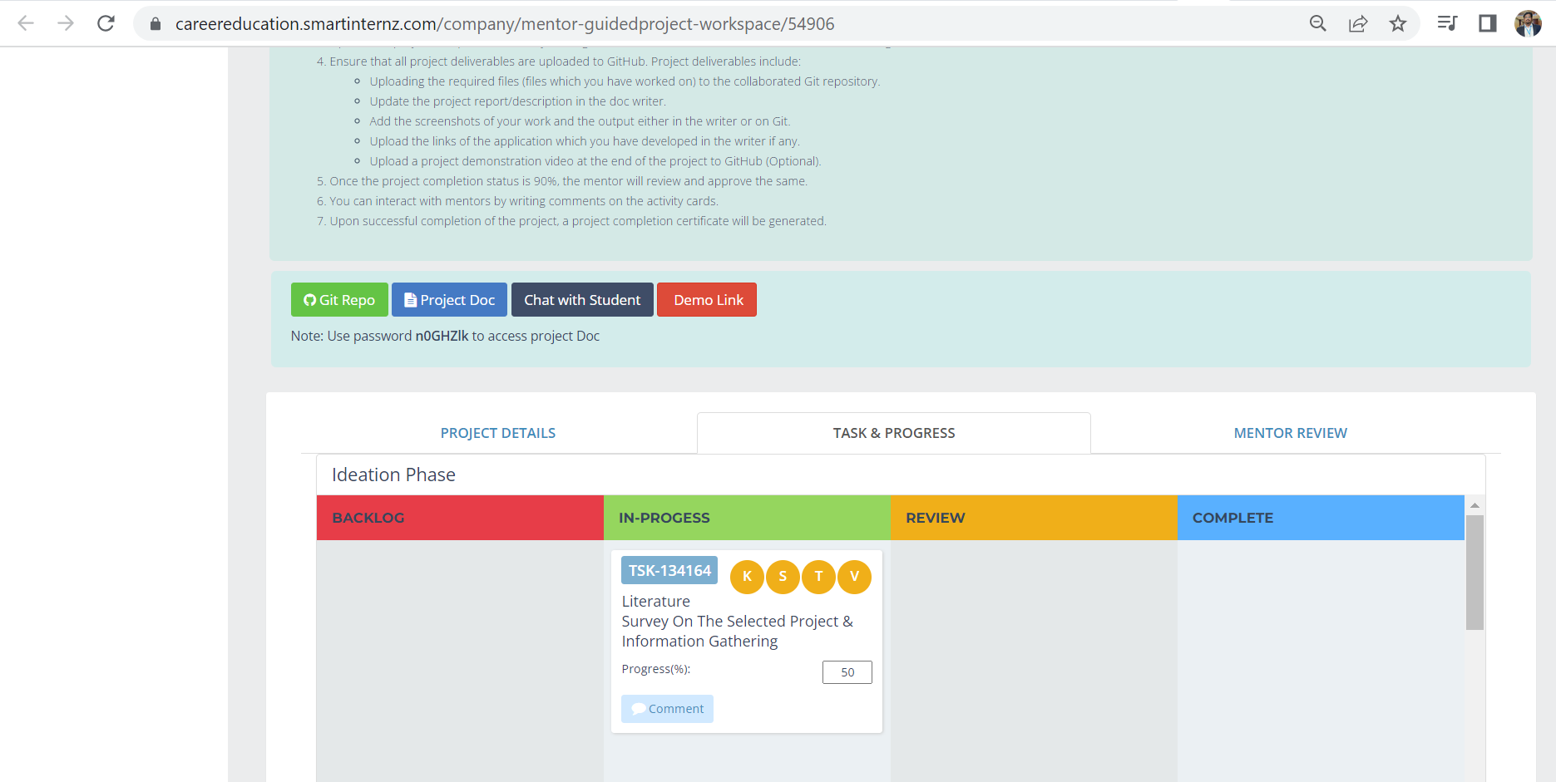

**Case 02:** Students might have submitted Phase 01 files in GitHub, but team leader did not assigned tasks to team members and therefore cards not created in Kanban board.

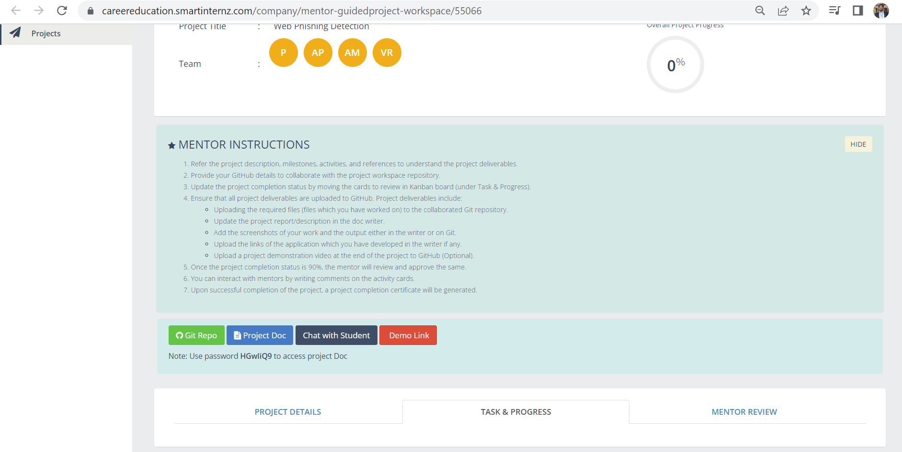

**Case 03:** Students might have submitted Phase 01 files in GitHub, but no proper order, half done file submitted, but in Kanban they moved files to 90%. In this case also industry mentor will not move cards to 100% (though he/she can move tool wise) because they did not work properly, so he/she will write mentor comments in cards, saying please rework on XYZ file etc.

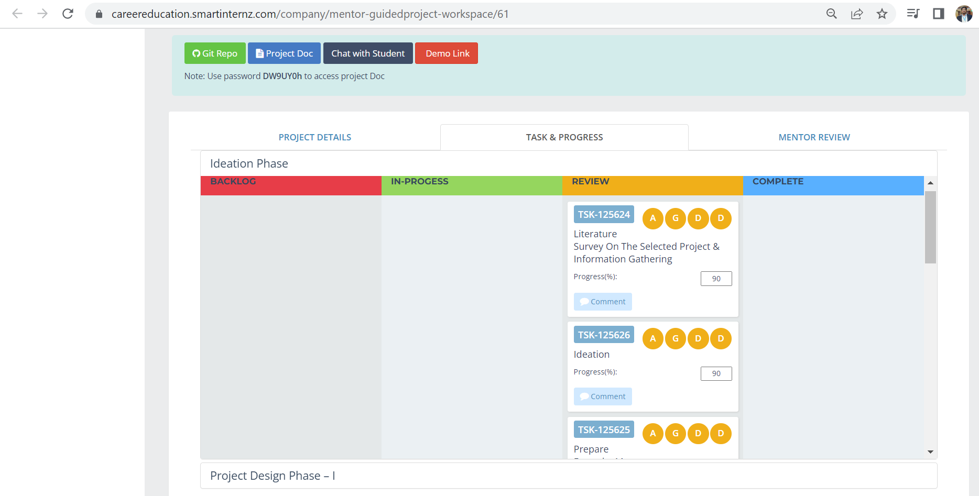

**Case 04:** Students might have submitted Phase 01 files in GitHub, and they also moved all cards in Kanban board to 90%. This is the only case Mentor can move cards to 100% if files also correctly submitted means.

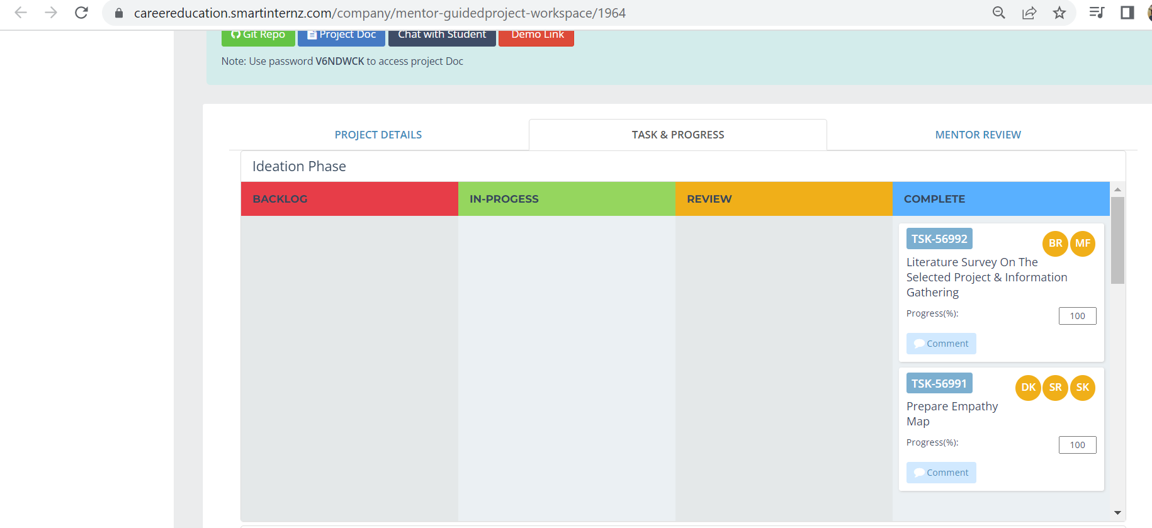

FYI, we have come across maximum Case 01, Case 02, Case 03. In which Case 01 percentage is more.

We have made you understand this process in AMA sessions and Knowledge sessions to all faculty mentors and evaluators saying that “*Please ask your student teams to not only submit files in GitHub, but also ensure they move cards to 90% (review state) in Kanban board*”.

We request you to make it happen what we discussed above. Thanks for understanding and looking forward for a great support from both Faculty Mentors and Evaluators. Thank you.